
FIFA World Cup 2026 Player Performance Analysis Using Python
Python Data Analysis Portfolio Project

July 29, 2026
by Lisa Koya
Cape Town

1. Project Overview 1
2. Project Objective 2
3. Dataset 2
4. Tools & Technologies 2
5. Skills to be Demonstrated 3
6. Project Phases 3
7. Learning Reflection 5
Phase 1 6
Lesson 1- Reading and Exploring a CSV Dataset Using Python 6
Lesson 2 – Understanding the Dataset Structure 10
Lesson 3 – Exploring Player Information 12
Lesson 4: Searching for a Specific Player 15
Lesson 5: Building a Menu-Driven Application 16
Lesson 6: Combining the Menu with Your Dataset 19
Lesson 7 – Functions 20
Lesson 8 – Dataset Information Function 22
Lesson 9 – Player Search Function 23
Lesson 10 – Keep the Menu Running 25
Lesson 11 – Flexible Player Search 25
Phase 2 - Exploratory Data Analysis (EDA) 26
Lesson 12 – Understanding the Data 27
Lesson 13- Analysis 2: Average Player Age 29
Lesson 14: Find the Top Goal Scorer 31
Lesson 16: Team Goal Analysis 34
Lesson 17: Most Valuable Player 36

1. Project Overview
This project focuses on analysing FIFA World Cup 2026 player performance data using Python. The project aims to explore player statistics, identify performance trends, and generate meaningful insights from the dataset. The project will be developed progressively as Python skills improve, beginning with Python fundamentals and later incorporating more advanced data analysis techniques.

2. Project Objective
The objective of this project is to apply Python programming skills to analyse a real-world football dataset. The project will demonstrate the ability to read, process, analyse, and interpret data while developing practical data analysis skills. As the project progresses, additional Python libraries and techniques will be incorporated to produce more advanced analyses and visualisations.

3. Dataset
Dataset Name:
FIFA World Cup 2026 Player Performance Dataset
Dataset Format:
CSV (.csv)
Dataset Description:
The dataset contains player performance information from the FIFA World Cup 2026. It includes player demographics, match statistics, physical performance metrics, and tournament performance indicators.

4. Tools & Technologies
Current tools:
- Python 3.11.5
- IDLE
- CSV Module
- GitHub
Future tools:
- Pandas
- NumPy
- Matplotlib
- SQL

5. Skills to be Demonstrated
This project will demonstrate:
- Python Programming
- File Handling
- Data Exploration
- Data Analysis
- Problem Solving
- Business Insight Generation
- Data Cleaning (future phase)
- Data Visualisation (future phase)

6. Project Phases
Phase 1 – Python Fundamentals (Current)
- Reading CSV files
- Understanding datasets
- Variables
- Loops
- Conditions
- Functions
- Basic calculations
Phase 2 – Intermediate Python
- Data processing
- Data validation
- Basic statistics
- Reusable functions
Phase 3 – Data Analysis
- Pandas
- NumPy
- Filtering
- Grouping
- Aggregation
Phase 4 – Data Visualisation
- Charts
- Graphs
- Performance comparisons
- Trend analysis
Phase 5 – Portfolio Project
- Final report
- GitHub documentation
- Business insights
- Professional presentation

7. Learning Reflection
This project is intentionally being built alongside my Python learning journey. Rather than waiting until I have mastered advanced Python libraries, I am applying newly learned concepts to a real dataset from the beginning. The project will evolve over-time as additional Python skills are acquired.

Phase 1

Lesson 1- Reading and Exploring a CSV Dataset Using Python
Objective
The objective of this lesson is to learn how to read a CSV dataset using Python's built-in csv module. This lesson introduces file handling and provides an understanding of how Python can be used to access and inspect real-world datasets before performing any analysis.
Python Concepts Covered
- Importing modules
- File handling
- Reading CSV files
- Using csv.reader()
- with open()
- for loops
- enumerate()
- break
- Displaying rows from a dataset
Objective:
- Read a CSV file using Python.
- Display the first few rows of a dataset.
- Display the column names.
- Count the number of columns.
- Count the number of rows.
- Understand the structure of a real-world dataset.
Theory
When a Data Analyst receives a new dataset, they don't immediately start answering questions. They first explore it by asking:
- What does the dataset contain?
- How many columns are there?
- How many records are there?
- What does each column represent?
This process is called data exploration.
Python Code
import csv
with open("fifa_world_cup_2026_player_performance.csv", "r") as file:
reader = csv.reader(file)
for i, row in enumerate(reader):
print(row)
if i == 4:
break
Code Explanation
The csv module is imported to allow Python to work with CSV files. The with open() statement opens the dataset in read mode and automatically closes the file after reading. The csv.reader() function reads the file one row at a time.
The enumerate() function assigns a number to each row while it is being read. The break statement stops the loop after the first five rows, allowing a quick preview of the dataset without printing thousands of records.
Output :
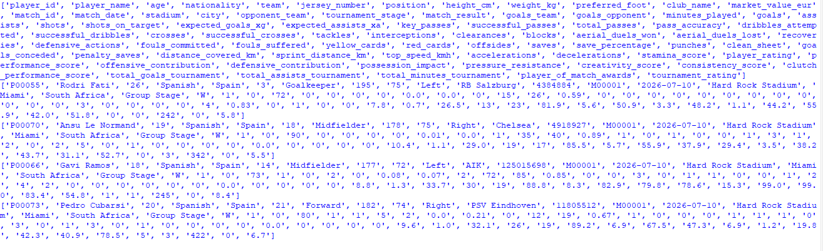
Task 2: Print the Column Names
headers = next(reader)
print("Column Names:")
print(headers)
Explanation
headers = next(reader)
- next() reads only the first row.
- The first row contains the column names (headers).
- Those headers are stored in the variable headers.
Output :
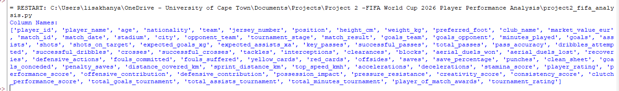
Task 3 : Count the Columns , Add:
print("\nNumber of Columns:")
print(len(headers))
Output :
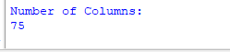
Count the number of rows?
Code :
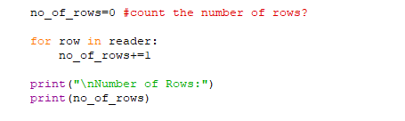
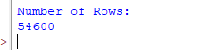
So, Understanding the Dataset
As a Data Analyst, you don't just know how much data you have, you also need to understand what the data contains.
After printing the column names, answer these questions in this documentation.
1. What type of dataset is this?
This dataset contains information about football players participating in the FIFA World Cup 2026.
2. What information does it contain?
The dataset contains player details, team information, match statistics, physical performance metrics, and tournament performance data.
3. Who could use this dataset?
- Football analysts
- Team coaches
- Scouts
- Sports journalists
- Sports scientists, etc

Lesson 2 – Understanding the Dataset Structure
Lesson Objective
By the end of this lesson, you will be able to:
- Read and understand the dataset headers.
- Identify which columns contain player information, match information, and performance statistics.
- Organise the dataset into logical categories.
- Decide which columns are most important for answering business questions.
Imagine your manager says:
"Find the best-performing players in the tournament."
Would you use all 75 columns?
No.
A Data Analyst first decides:
Which columns are actually useful?
Task 1 : Practical Exercise 1 – Print Each Column on Its Own Line
Instead of printing one long list of headers, let's make it easier to read.
print("Dataset Columns:\n")
for header in headers:
print(header)
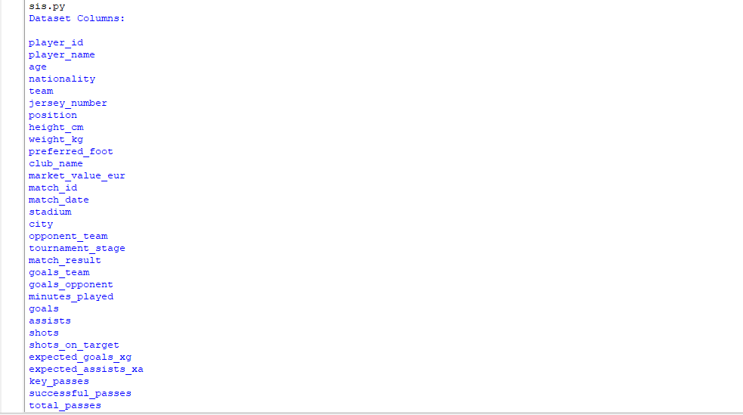
Task 2:Number the Columns
Replaced the loop with:
for number, header in enumerate(headers, start=1):
print(number, "-", header)
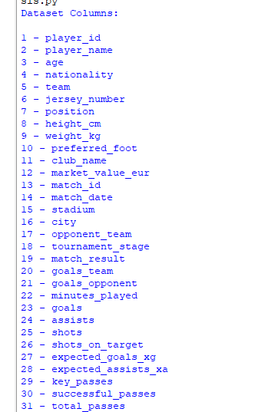
This is useful because if someone asks, "What's column 25?" you can find it quickly.
Lesson 2 Summary
During this lesson, the dataset headers were explored in detail. The column names were displayed individually and numbered to make the dataset easier to understand. This helped identify the different types of information available for future analysis and prepared the dataset for the next stages of the project.

Lesson 3 – Exploring Player Information
Lesson Objective
By the end of this lesson, you will be able to:
- Access individual rows of data.
- Retrieve information about a specific player.
- Understand how data is stored in a CSV file.
- Search for information using Python.
Task 1: Print the First Player Record
first_player = next(reader)
print("First Player Record:")
print(first_player)
Task 2: Print Each Value on a New Line
Replacing “print(first_player”)
With:
for value in first_player:
print(value)
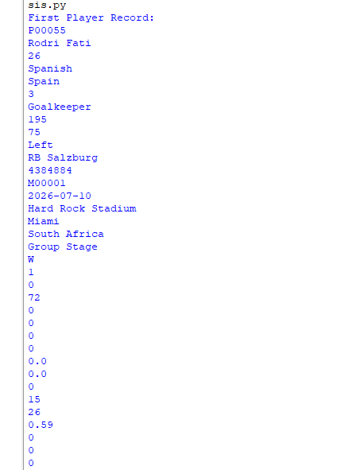
See each piece of information on its own line.
Task 3 : Match Headers to Values
Replacing the loop with :
for header, value in zip(headers, first_player):
print(header + ":", value)
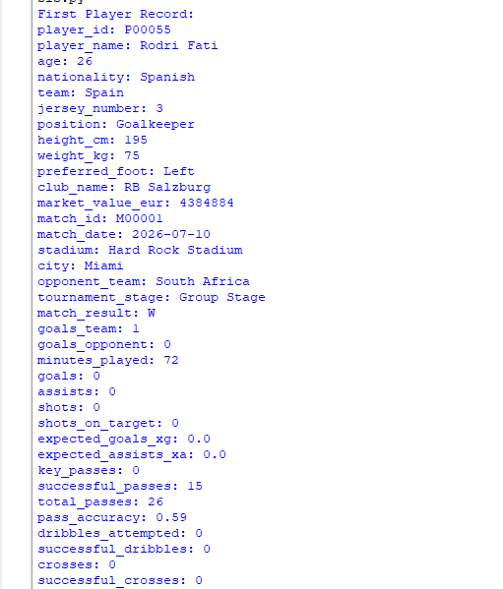
This is much easier to understand because every value is labelled.
Lesson 3 – Summary
Objective
To understand how individual player records are stored in a CSV file and learn how to retrieve and display information for a single player.
Skills used
- Reading an individual record
- Using next()
- Working with lists
- Using zip()
- Displaying labelled data
Reflection
This lesson demonstrated how a single row in a CSV dataset represents the information of a single player. Using zip() made the output much easier to understand by pairing each value with its corresponding column name. This technique is useful for inspecting records before performing analysis

Lesson 4: Searching for a Specific Player
Lesson Objective
By the end of this lesson, you will be able to:
- Search through a CSV dataset.
- Find a specific player by name.
- Use if statements with loops.
- Stop the search once the player is found.
This is one of the first real tasks a Data Analyst performs when working with data.
Theory
Imagine your manager asks:
"Can you find all the information about Lionel Messi?"
Instead of manually scrolling through 54,000+ rows, we'll let Python search for us.
Task 1 : Search for a Player
Player_id = input("Enter a player's id: ")
with open("fifa_world_cup_2026_player_performance.csv", "r") as file:
reader = csv.reader(file)
headers = next(reader)
found = False
for row in reader:
if player_id.lower() == row[0].lower():
print("\nPlayer Found!\n")
for header, value in zip(headers, row):
print(header + ":", value)
found = True
break
if not found:
print("Player not found.")
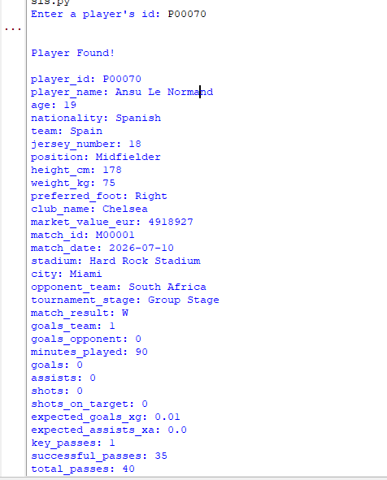
Reflection
This lesson introduced searching within a dataset. Instead of manually looking through thousands of rows, Python automatically searched for a player's name and displayed all available information. This demonstrates how programming can make data retrieval much more efficient.

Lesson 5: Building a Menu-Driven Application
Lesson Objective
By the end of this lesson, you will be able to:
- Create a menu for your program.
- Allow users to choose different options.
- Organise your code into a simple application.
- Build the foundation for your FIFA Player Analysis System.
Theory
Instead of writing a different Python program for every task, professional developers create one program with a menu. For example:
=================================
FIFA PLAYER ANALYSIS SYSTEM
=================================
1. View Dataset Information
2. Display Column Names
3. Search for a Player
4. Exit
Choose an option:
The user enters a number, and the program performs that task.
Task 1 : Create a menu in new file
print("=" * 40)
print(" FIFA PLAYER ANALYSIS SYSTEM")
print("=" * 40)
print("1. View Dataset Information")
print("2. Display Column Names")
print("3. Search for a Player")
print("4. Exit")
choice = input("\nChoose an option: ")
print("\nYou selected option:", choice)
Task 2: Respond to the Choice
if choice == "1":
print("\nDisplaying dataset information...")
elif choice == "2":
print("\nDisplaying column names...")
elif choice == "3":
print("\nSearching for a player...")
elif choice == "4":
print("\nThank you for using the system!")
else:
print("\nInvalid option.")
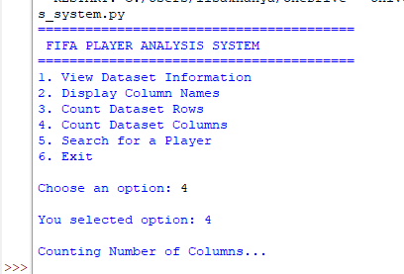
Reflection
This lesson introduced the concept of a menu-driven application. Instead of writing separate programs for different tasks, a single application can provide multiple features through a user-friendly menu. This approach improves organisation and prepares the project for additional functionality.

Lesson 6: Combining the Menu with Your Dataset
Objective
By the end of this lesson, you'll be able to connect your menu to your FIFA dataset so that each menu option actually performs a task.
This is the point where your program starts becoming a real application.
Task 1: Create a Variable for the CSV File
with open(file_name, "r") as file:
reader = csv.reader(file)
headers = next(reader)
print("\nDataset Columns")
print("-" * 30)
for number, header in enumerate(headers, start=1):
print(f"{number}. {header}")
What happens?
When the user chooses Option 1, your program will display something like:
Dataset Information
----------------------
Number of Columns: 75
Number of Rows: 54600
Now your menu isn't just displaying text, it is actually analysing the dataset.
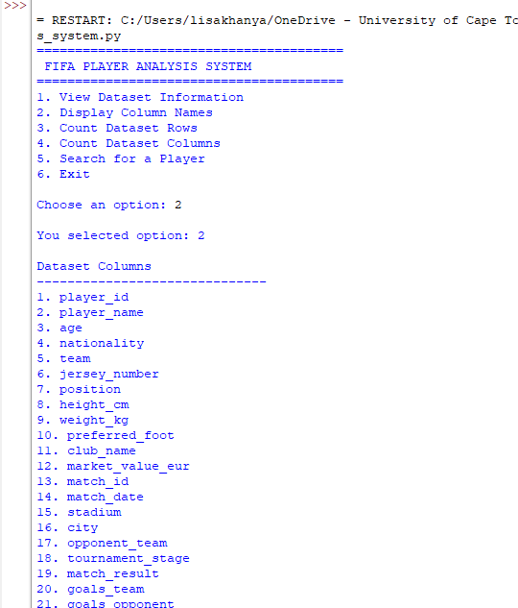
Reflection
This lesson connected the user interface to the dataset. Instead of displaying placeholder messages, the application now retrieves real information from the FIFA dataset. This is an important step towards building a fully functional data analysis application.

Lesson 7 – Functions
Why Functions?
Professional programmers don't put everything in one big block of code. Instead, they organise it into functions.
Above menu:
import csv
file_name = "fifa_world_cup_2026_player_performance.csv"
def display_columns():
with open(file_name, "r") as file:
reader = csv.reader(file)
headers = next(reader)
print("\nDataset Columns")
print("-" * 30)
for number, header in enumerate(headers, start=1):
print(f"{number}. {header}")
Task 2 : Call the Function
Replaced:
elif choice == "2":
with open(file_name, "r") as file:
etc
with just:
elif choice == "2":
display_columns()
Program will behave exactly the same, but the code is much cleaner.
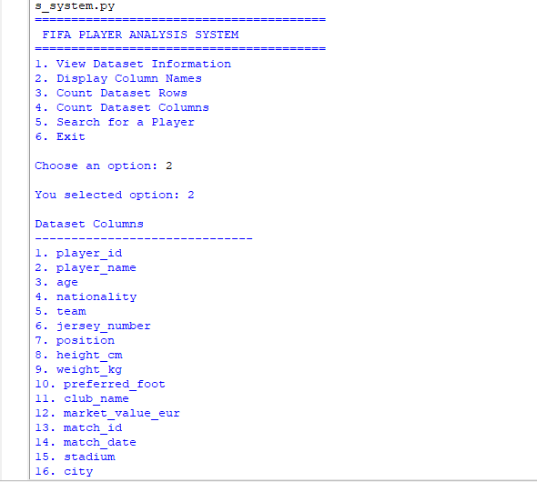
Lesson 7 – Using Functions
Objective
Learn how to organise Python code into reusable functions.
Skills used
- Defining functions with def
- Calling functions
- Organising code
- Improving readability and maintainability
Reflection
Functions allow a program to be broken into smaller, reusable sections. This makes the code easier to read, test, and maintain. As the FIFA Player Analysis System grows, using functions will keep the application organised and professional.

Lesson 8 – Dataset Information Function
Objective
Create a function that displays:
- Total number of rows
- Total number of columns
instead of just printing a message.
Task 1 : Create the Function
Above the menu, below display_columns(), add:
def dataset_information():
with open(file_name, "r") as file:
reader = csv.reader(file)
headers = next(reader)
row_count = 0
for row in reader:
row_count += 1
print("\nDATASET INFORMATION")
print("-" * 30)
print("Total Columns:", len(headers))
print("Total Rows:", row_count)
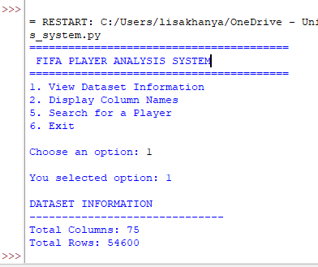
Reflection
A dedicated function was created to display key information about the dataset. This reduced code duplication and made the application more organised. The function can be reused whenever dataset information is needed.

Lesson 9 – Player Search Function
Objective
Create a working search feature where the user types a player's name and the program displays all the information about that player.
Task 1 : Create the Function
Above menu, add:
def search_player():
player_id = input("\nEnter player's id: ")
with open(file_name, "r") as file:
reader = csv.reader(file)
headers = next(reader)
found = False
for row in reader:
if player_id.lower() == row[0].lower():
print("\nPLAYER FOUND") print("-" * 30)
for header, value in zip(headers, row):
print(f"{header}: {value}")
found = True
break
if not found:
print("\nPlayer not found.")
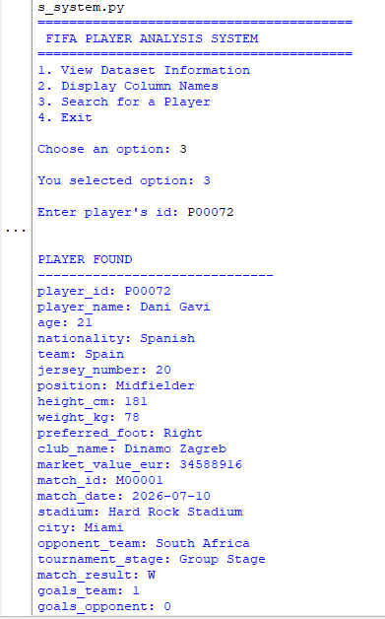
Reflection
A player search feature was added to the FIFA Player Analysis System. Users can enter a player's name, and the application searches the dataset to display the corresponding record. This demonstrates how Python can quickly retrieve information from large datasets.

Lesson 10 – Keep the Menu Running
Objective
Learn how to use a while loop so your menu keeps appearing until the user chooses to exit.
Task 1 : Wrap Your Menu in a Loop
Before the first print("=" * 40), add:
running = True
while running:
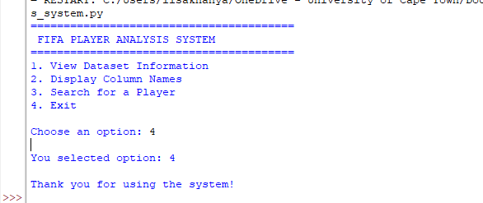
Reflection
A while loop was implemented to keep the application running after each task was completed. This allows users to perform multiple operations without restarting the program, making the application more user-friendly and similar to professional software.

Lesson 11 – Flexible Player Search
Objective
Improve the search feature by allowing partial name searches.
Skills Learned
- Using the in operator
- Working with strings
- Improving user experience
- Searching text efficiently
Task :
Inside search_player() function, you currently have:
if player_name.lower() == row[0].lower():
This checks for an exact match.
if player_name.lower() in row[0].lower():
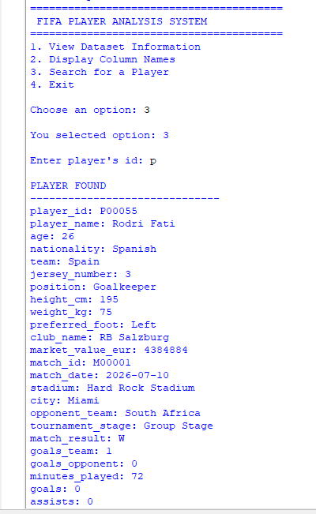
Reflection
The player search function was enhanced by replacing an exact comparison with a partial string search. Users can now find players by entering only part of a name, making the application more flexible and easier to use.

Phase 2 - Exploratory Data Analysis (EDA)
Phase Objective
The goal of this milestone is to explore the FIFA World Cup 2026 Player Performance dataset and answer meaningful questions using Python.
By the end of this milestone, you'll be able to:
- Calculate statistics
- Find top-performing players
- Compare teams
- Analyse player performance
- Produce insights that could help coaches, scouts, or analysts

Lesson 12 – Understanding the Data
Objective
Before we calculate anything, we need to know what each column contains. A Data Analyst always starts by understanding the available data.
Column Categories
Player Information
- player_id
- player_name
- age
- nationality
- team
- jersey_number
- position
- preferred_foot
- club_name
Physical Information
- height_cm
- weight_kg
- market_value_eur
Match Information
- match_id
- match_date
- stadium
- city
- opponent_team
- tournament_stage
- match_result
Performance Statistics
- goals_team
- goals_opponent
- minutes_played
- goals
- assists
- shots
- shots_on_target
- expected_goals_xg
for analysis , How many players are in the dataset?
def total_players():
with open(file_name, "r") as file:
reader = csv.reader(file)
next(reader)
player_count = 0
for row in reader:
player_count += 1
print("\nTOTAL PLAYERS")
print("-" * 25)
print("Total Players:", player_count)
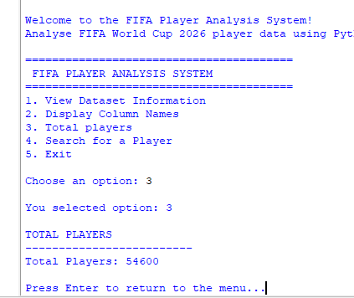
Reflection
The dataset contains player, match, and performance information. Grouping the columns into categories makes it easier to identify which variables will be used for future analysis and answering business questions.

Lesson 13- Analysis 2: Average Player Age
Objective
Calculate the average age of all players in the FIFA World Cup 2026 dataset.
Skills used
- Summing numerical values
- Calculating averages
- Using float()
- Performing basic statistical analysis
Business Question
What is the average age of players in the tournament?
This is a common statistic in sports analytics. It helps coaches and analysts understand whether a tournament is dominated by younger or more experienced players.
Creating a new function , average_age
def average_age():
with open(file_name, "r") as file:
reader = csv.reader(file)
headers = next(reader)
total_age = 0
player_count = 0
for row in reader:
total_age += float(row[2])
player_count += 1
average = total_age / player_count
print("\nAVERAGE PLAYER AGE")
print("-" * 25)
print("Average Age:", round(average, 2), "years")
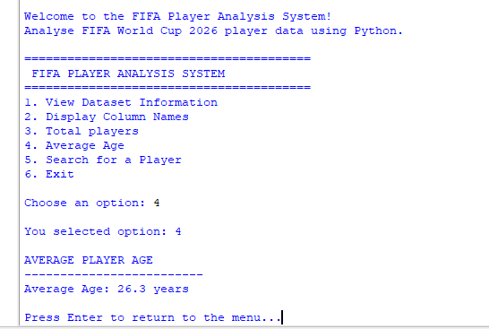
Reflection
The average age of players was calculated by summing all player ages and dividing by the total number of players. This provides an overview of the age profile of the tournament and demonstrates how Python can be used to calculate descriptive statistics.

Lesson 14: Find the Top Goal Scorer
Objective
Identify the player who scored the highest number of goals in the tournament.
Skills used
- Finding the maximum value in a dataset
- Comparing values using if
- Tracking related information (player name and goals)
Business Question
Who scored the most goals in the tournament?
This is a real-world analysis that football analysts, coaches, and journalists perform.
The goals row is row 23 , but index says row 22, so new function ,
def top_goal_scorer():
with open(file_name, "r") as file:
reader = csv.reader(file)
next(reader)
highest_goals = -1
best_player = ""
for row in reader:
goals = int(row[22])
if goals > highest_goals:
highest_goals = goals
best_player = row[1]
print("\nTOP GOAL SCORER")
print("-" * 25)
print("Player:", best_player)
print("Goals:", highest_goals)
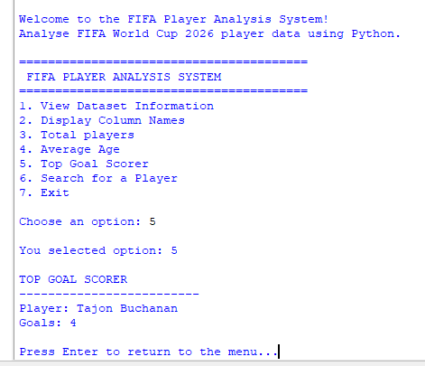
Reflection
This lesson focused on identifying the top goal scorer in the FIFA World Cup 2026 dataset. By comparing each player's goal total, the program was able to determine the player with the highest number of goals. The analysis showed that Tajon Buchanan was the tournament's top goal scorer with 4 goals. This exercise demonstrated how Python can be used to identify maximum values in a dataset and highlight top-performing players, which is a common task in sports data analysis.

Lesson 15: Top 10 Goal Scorers
Objective
Rank the ten players with the highest number of goals scored in the tournament.
Skills used
- Creating lists
- Appending data
- Sorting with sort()
- Using lambda
- Ranking data
- Displaying the top results
Business Question
Who are the Top 10 goal scorers in the tournament?
Instead of finding only the best player, we'll rank the top 10. This is a common analysis in sports, business, and finance.
def top_10_goal_scorers():
with open(file_name, "r") as file:
reader = csv.reader(file)
next(reader)
players = []
for row in reader:
player = row[1]
goals = int(row[22])
players.append([player, goals])
players.sort(key=lambda x: x[1], reverse=True)
print("\nTOP 10 GOAL SCORERS")
print("-" * 35)
for i, player in enumerate(players[:10], start=1):
print(f"{i}. {player[0]} - {player[1]} Goals")
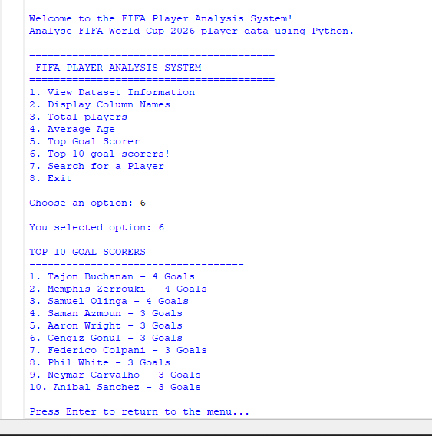
Reflection
The dataset was analysed to identify the top ten goal scorers. After sorting all players by the number of goals scored, the results showed that Tajon Buchanan, Memphis Zerrouki, and Samuel Olinga shared first place with 4 goals each. The remaining players in the top ten scored 3 goals, indicating that goal scoring was fairly balanced across the tournament rather than being dominated by a single player. This type of ranking helps analysts identify top performers and compare player contributions.

Lesson 16: Team Goal Analysis
Objective
Calculate the total number of goals scored by each team during the tournament.
Skills used
- Using dictionaries
- Grouping data
- Summing values by category
- Sorting grouped results
Business Question
Which teams scored the most goals in the tournament?
This teaches you how to group data by a category (team) and calculate totals.
def team_goals():
with open(file_name, "r") as file:
reader = csv.reader(file)
next(reader)
teams = {}
for row in reader:
team = row[4]
goals = int(row[22])
if team in teams:
teams[team] += goals
else:
teams[team] = goals
print("\nTEAM GOAL TOTALS")
print("-" * 35)
sorted_teams = sorted(teams.items(), key=lambda x: x[1], reverse=True)
for team, goals in sorted_teams:
print(f"{team}: {goals} goals")
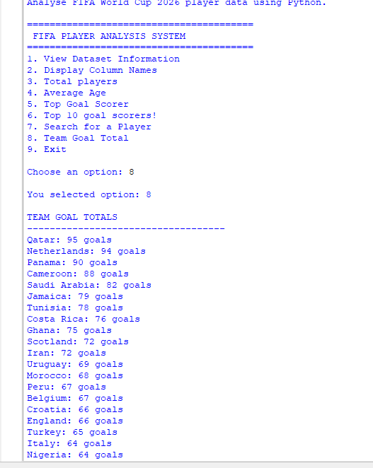
Reflection
This lesson analysed team performance by grouping players according to their teams and calculating the total goals scored by each team. The analysis showed that Qatar scored the highest number of goals (95), followed closely by the Netherlands (94) and Panama (90). These results indicate that the tournament featured several strong attacking teams, with only small differences separating the top performers. This type of grouped analysis is widely used in data analytics to compare performance across categories.

Lesson 17: Most Valuable Player
Objective
Identify the player with the highest market value in the FIFA World Cup 2026 dataset.
Skills used
- Finding the maximum value in a financial dataset
- Working with decimal numbers using float()
- Formatting currency values
- Identifying top-performing records
Business Question
Who is the most valuable player in the tournament?
This is similar to finding the top goal scorer, but instead of using goals, we'll use market_value_eur.
It is row row 12 , index says 11 , so , here is its function that was created ,
def most_valuable_player():
with open(file_name, "r") as file:
reader = csv.reader(file)
next(reader)
highest_value = 0
best_player = ""
for row in reader:
value = float(row[11])
if value > highest_value:
highest_value = value
best_player = row[1]
print("\nMOST VALUABLE PLAYER")
print("-" * 30)
print("Player:", best_player)
print("Market Value: €{:,.2f}".format(highest_value))
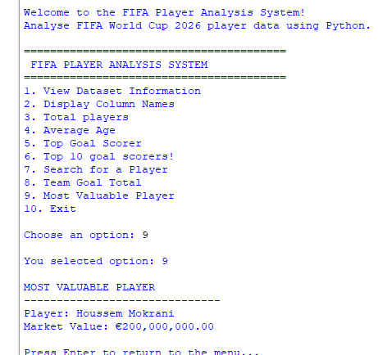
Reflection
This lesson analysed the market value of players to identify the most valuable player in the tournament. By comparing each player's market value, the program found that Houssem Mokrani had the highest estimated market value of €200,000,000.00. This analysis demonstrates how Python can be used to identify the highest-valued records and analyse financial information within a dataset.

Lesson 18: Average Goals by Position
Objective
Calculate the average number of goals scored by players in each playing position.
Skills used
- Grouping data
- Using dictionaries with multiple values
- Calculating averages
- Comparing categories
Business Question
Which playing position scores the most goals on average?
Instead of analysing individual players or teams, we're now analysing positions (Forward, Midfielder, Defender, Goalkeeper).
This introduces another important data analysis skill: calculating averages for groups.
def average_goals_by_position():
with open(file_name, "r") as file:
reader = csv.reader(file)
next(reader)
positions = {}
for row in reader:
position = row[6]
goals = int(row[22])
if position not in positions:
positions[position] = [0, 0]
positions[position][0] += goals
positions[position][1] += 1
print("\nAVERAGE GOALS BY POSITION")
print("-" * 35)
for position in positions:
total_goals = positions[position][0]
total_players = positions[position][1]
average = total_goals / total_players
print(f"{position}: {average:.2f} goals")
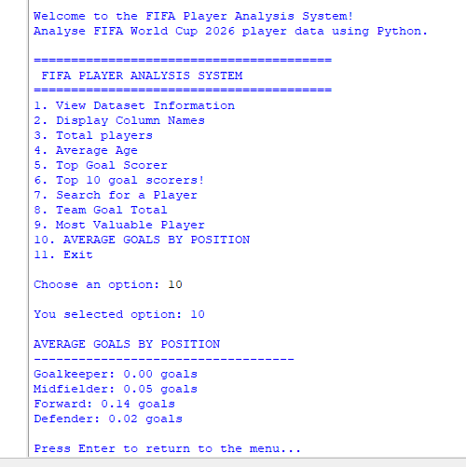
Reflection
This lesson analysed the average number of goals scored by players in different playing positions. The results showed that forwards had the highest average goals (0.14), followed by midfielders (0.05) and defenders (0.02), while goalkeepers scored no goals. These findings reflect the different responsibilities of each position and demonstrate how grouping and averaging can provide meaningful insights from data.

Lesson 19: Top Assist Provider
Objective
Identify the player with the highest number of assists in the FIFA World Cup 2026 dataset.
Skills used
- Finding the maximum value in a dataset
- Comparing numerical values
- Analysing player creativity
- Reusing Python logic for different analyses
Business Question
Which player provided the most assists in the tournament?
Goals are important, but assists measure a player's ability to create scoring opportunities for teammates. This is another key performance metric in football analytics.
Assists is in row 24, so index is 23, this is the function created ,
def top_assist_provider():
with open(file_name, "r") as file:
reader = csv.reader(file)
next(reader)
highest_assists = -1
best_player = ""
for row in reader:
assists = int(row[23])
if assists > highest_assists:
highest_assists = assists
best_player = row[1]
print("\nTOP ASSIST PROVIDER")
print("-" * 30)
print("Player:", best_player)
print("Assists:", highest_assists)
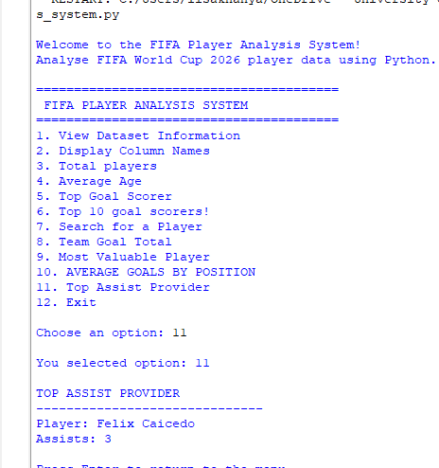
Reflection
This lesson analysed player assists to identify the tournament's top assist provider. By comparing the number of assists recorded by each player, the program found that Felix Caicedo provided the highest number of assists with 3. This analysis highlights the importance of playmakers in creating goal-scoring opportunities and demonstrates how Python can be used to evaluate different aspects of player performance.

Lesson 20: Best Shooting Accuracy
Business Question
Which player has the best shooting accuracy?
A player may take many shots, but what matters is how many are on target.
We'll calculate:
$$\text{Accuracy}=\frac{\text{Shots on Target}}{\text{Shots}}×100$$
This is the first lesson where I create a calculated metric, not just read a value directly from the dataset.
def best_shooting_accuracy():
with open(file_name, "r") as file:
reader = csv.reader(file)
next(reader)
highest_accuracy = 0
best_player = ""
for row in reader:
shots = int(row[24])
shots_on_target = int(row[25])
if shots > 0:
accuracy = (shots_on_target / shots) * 100
if accuracy > highest_accuracy:
highest_accuracy = accuracy
best_player = row[1]
print("\nBEST SHOOTING ACCURACY")
print("-" * 35)
print("Player:", best_player)
print("Accuracy: {:.2f}%".format(highest_accuracy))
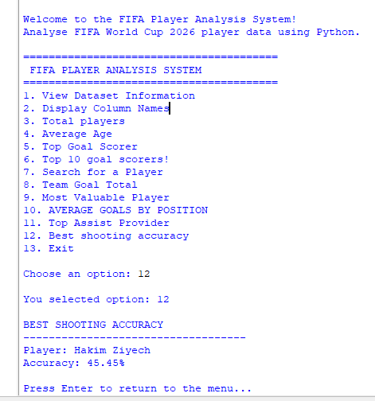
Reflection
This lesson analysed shooting accuracy by calculating the percentage of shots that were on target for each player. The analysis found that Hakim Ziyech had the highest shooting accuracy at 45.45%. Unlike previous lessons that used existing values, this analysis created a new performance metric by combining two different columns. This demonstrates how Python can be used to derive meaningful insights from raw data.
Lesson 21: Highest Expected Goals (xG)
Objective
Identify the player with the highest Expected Goals (xG) value in the tournament.
Skills used
- Working with decimal values
- Comparing floating-point numbers
- Analysing advanced football statistics
- Identifying players with the best scoring opportunities
Business Question
Which player has the highest Expected Goals (xG)?
What is xG?
Expected Goals (xG) estimates the quality of a player's scoring chances.
- A higher xG means a player had better opportunities to score.
- A player can have a high xG but few actual goals if they missed many chances.
This statistic is widely used in professional football analytics.
def highest_xg_player():
with open(file_name, "r") as file:
reader = csv.reader(file)
next(reader)
highest_xg = -1
best_player = ""
for row in reader:
xg = float(row[26])
if xg > highest_xg:
highest_xg = xg
best_player = row[1]
print("\nPLAYER WITH HIGHEST EXPECTED GOALS (xG)")
print("-" * 45)
print("Player:", best_player)
print("Expected Goals (xG):", round(highest_xg, 2))
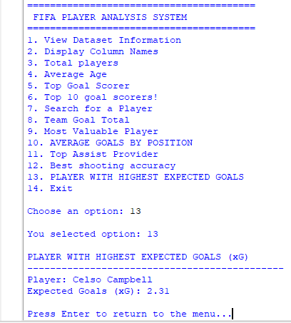
Reflection
This lesson analysed the Expected Goals (xG) statistic to identify the player with the highest quality scoring opportunities during the tournament. The analysis found that Celso Campbell had the highest xG value of 2.31, indicating that he generated the best scoring chances. This demonstrates how Python can be used to analyse advanced football metrics and provide deeper insights than simply counting goals.

